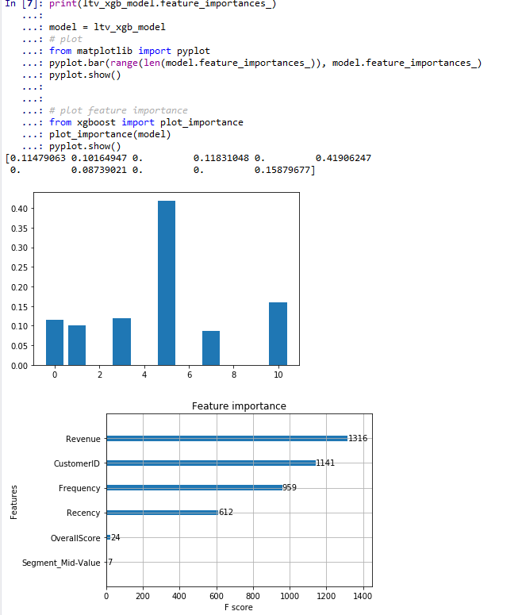

Hi Sophia,  1- Yes. First, we identify the classes in LTV then predict it for the future. 2- Better to save the model as pkl and use. You can either create a flask server, get the data and run the prediction algorithm. Otherwise you can run the model regularly, assign the predicted the classes to customer ids and save it in database. So everyone can fetch that data and use.  3- Ideally Customer ID should get removed.